Loose Lifting
Ballast Brush Booklet

Universal hydraulic attachment
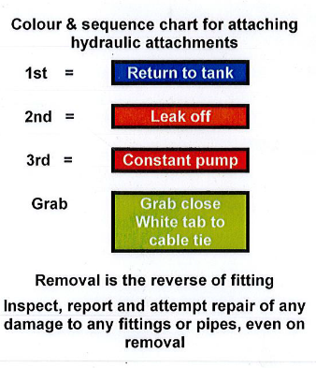

LLBB03,07,08,09, 10 (Richter & Muller):
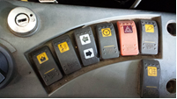
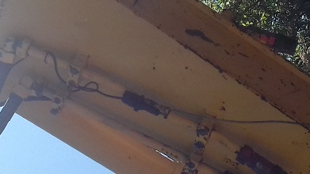
Electrical connection and activation: Rail lights are activated through the switch on the ballast brush. Electrical connection to the machine is through the din plug, meaning the din switch must be on in the cab. This also provides power to raise/lower door for height adjustment. On a JS this is usually automatic activation, if not, is on the hazard lights switch, highlighted in orange.

Height adjustment: clearing height set through grab rotating function
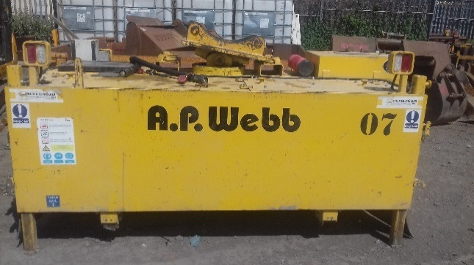
Technique: The broom rotates when the grab open/close function is activated and the conveyor belts start turning. Opening or closing the grab decides on the belt ejection to the right or the left. Setting the height of ejection flap will adjust the distance the ballast is ejected.

